Building an Argument
Activity 1.13

As you read the article, identify the claim and highlight evidence that support that claim.

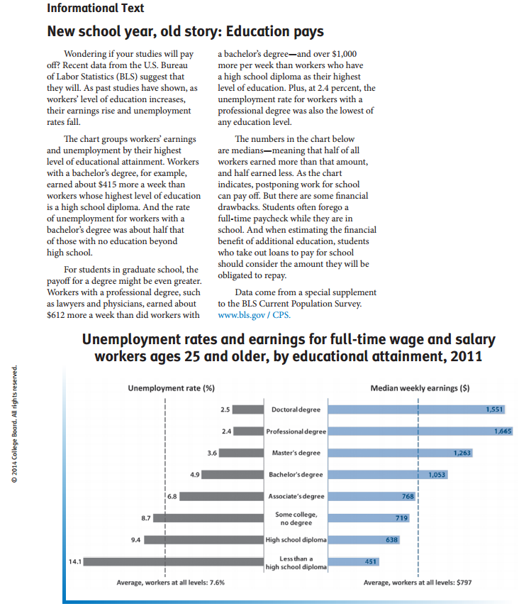

Answer the following questions clearly and completely:

- What claim does this article make?

- How does the article support the claim?

- What is the source of this information?

- How do you view this source? Do you think the data cited are reliable? Why or why not?

- How does the presentation of data in a chart aid the reader?

THINKING:
- Describe what makes a claim persuasive.

- Choose one of the benefits given in the video “Five Ways Ed Pays”—other than greater wealth—and write a claim for that benefit. [other benefits were more security, better health, close family, and stronger community]

