Targeting Your Audience
Act. 1.17: “An Early Start on College”

- As you read the following article, identify the AUDIENCE.
- Then annotate the article to identify the elements of audience: hook/grabber, claim, supporting evidence, call to action, and conclusion.

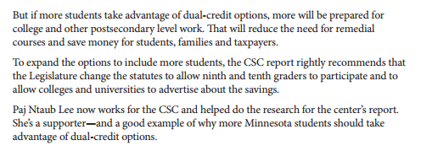

Answer the following questions:

- What is the central claim in this editorial? How does the author introduce it? (in other words, what is the hook?)

- The CSC study is used as evidence in this editorial. What claim does it support? How effective is it as a source to support the editorial’s central claims?

- What call to action is offered in the editorial? Does the article effectively motivate you as a ninth grader to take action? Why or why not?

- How does the conclusion support the central claim and convince readers to believe the writer’s evidence?

- The StarTribune editorial addresses multiple audiences. Identify each audicence. Use quotes you highlighted to show how each audience is referenced or directly addressed in the text.

- How effective is this piece at appealing to high school students? Why? What types of evidence and which rhetorical appeals are effective for high school students?

